**Final year dissertation.**

**

**WHAT I HAVE DONE SO FAR; is at the bottom of all the pages;**

**x**

Focusing project on ceramides; such as the Molecule is DPCE;

Includes computing software of putty, linux, command prompt;

**Simulations that neeed to be done for the project;( most have been done by me I’d say 80% on linux)**

In this project you will create a lipid bilayers comprising of your model lipid using the online membrane builder CHARMM-GUI http://www.charmm-gui.org/?doc=input/membrane.bilayer (for atomistic simulations) and using MARTINI lipids http://cgmartini.nl/index.php/force-field-parameters/lipids (for coarse grained simulations).

You will set up modelling system and simulate y

There are several different models for lipids, with brief division to fully atomistic (all atoms present) and coarse-grained (a few atoms are grouped together to form larger particles).

While the fists models allow to consider lipids in details, the second model allows to consider larger systems, more relevant to real-life applications. These projects are focused on comparison of atomistic model (using CHARMM36 force field) with coarse grained models (using MARTINI force-field). Each project focused on one specific lipid.

Ethics project has been completed; no wet labs just/ computing.

Also completed my risk assessment for the project;

**RISK ASSESSMENT FOR RESEARCH AND PROJECTS**

**COVER SHEET.**

|  |  |
| --- | --- |
| Student’s surname | Kazmi |
| Student’s forenames | Sidrah |
| Section of School | Pharmaceutical science / school of engineering and science |
| Degree | Pharmaceutical science |
| Title of Project | Molecular dynamics simulations of lipid membranes. Comparison between atomistic and coarse grained approach. |
| Brief description of the project | Looking into different types of lips and the comparing the different approaches to analyse them |
| Supervisor’s name | Dr Anna Akinshina |
| Reserve supervisor in case of absence. | Dr David Pye |
| Locations where work will be carried out | University/lecture rooms |

It is the responsibility of the PI / Supervisor to ensure the risk assessment is suitable and sufficient and that risk assessments are reviewed should any significant changes to the project / research be made.

**Simulations document below;**

**Molecular dynamics projects involving membrane simulations and analysis**

**Before the beginning: Software required.**

**Molecular Dynamics Simulations**

Will be performed using Gromacs package <http://www.gromacs.org/>

Gromacs is already installed in Linux servers, you don’t need to install it.

But you will need to learn how to use it.

You will need references to the code – use those:

<http://www.gromacs.org/Gromacs_papers>

**Software needed:**

**VMD** – VMD stands for Visual Molecular Dynamics. Free download from: <http://www.ks.uiuc.edu/Research/vmd/>.

VMD is a molecular visualization program for displaying, animating, and analyzing large biomolecular systems using 3-D graphics and built-in scripting. VMD supports computers running MacOS X, Unix, or Windows, is distributed free of charge, and includes source code.

**PuTTY & WinSCP:**

<https://winscp.net/eng/download.php#download2>

<https://winscp.net/eng/download.php#putty> OR <https://www.chiark.greenend.org.uk/~sgtatham/putty/latest.html>

WinSCP main function is file transfer between a local and a remote computer. You use WinSCP to transfer files from the HPC cluster to your computer (files to visualise in VMD, files to make graphs in excel)

PuTTY is a free and open-source terminal emulator, serial console and network file transfer application. You need PuTTY to connect to the cluster and run your simulations. This software emulate a linux terminal (window where you work).

You can download and install these software in your laptops & home computers. It is free software.

**Software installation ON CAMPUS:**

You need to follow the steps below to install VMD, WinSCP and PuTTY onto any University PC on campus.

* Press Win + R to open the ‘Run’ dialogue
* Cut and paste the following portable link:

**\\isdads.salford.ac.uk\files\ISDCoreApps_01\apps\CENTRAL\PuTTY_WinSCP_VMD\install.bat**

* click ‘OK’

**----------------------------------------------------------------------------------------------------------------------------------**

**Configure host name**

Host name is the name of remote computer (linux server, HPC cluster) you need to log in.

When log in from the campus use host name: **uos-p-bioi-01.isdads.salford.ac.uk**

Save these host names in your WinSCP / PuTTY configurations so you don’t need to type them every time you login.

**Configure WinSCP (what to do first time)**

**WinSCP – login**

host name:

uos-p-bioi-01.isdads.salford.ac.uk – ON CAMPUS

146.87.15.160 – OFF CAMPUS

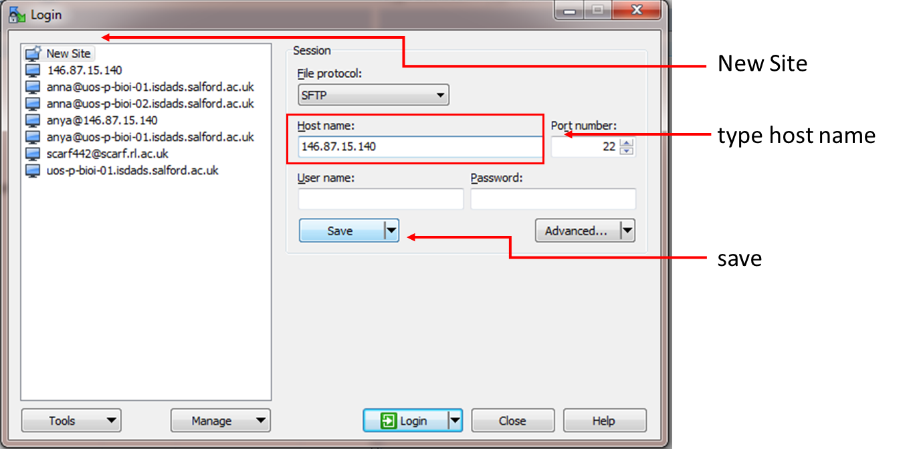

**When IP / host is saved it is easier to open the terminal from saved sessions**

**Copy files from/to cluster (WinSCP)**

open WinSCP

drag and drop files between two panels

|  |  |
| --- | --- |
| **Left panel:**  Your computer files | **Right panel:**  Cluster files |

Important! Don’t delete by accident files on cluster – right panel – you can’t restore them! Your results will be lost.

**WinSCP panels**

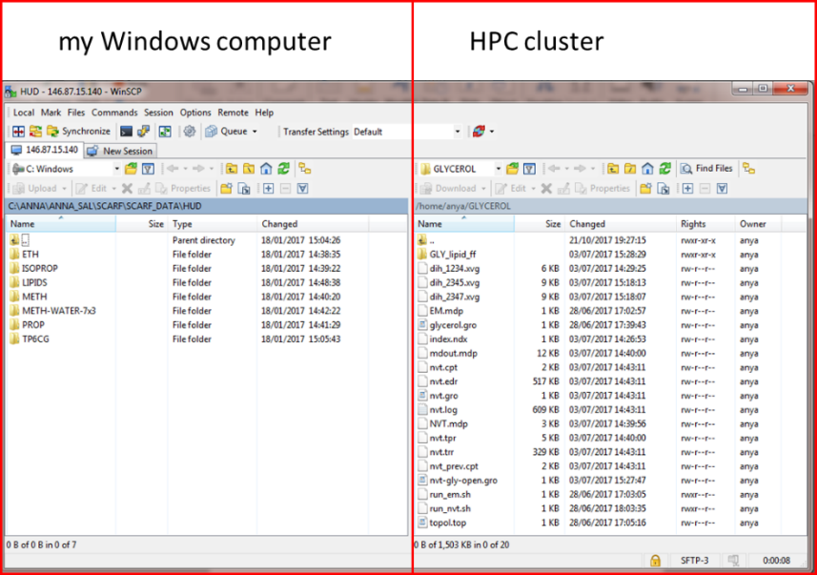

Mac Users: There are no WinSCP for Mac but the alternative is the code called Cyberduck (you need to download it)

**Login to HPC cluster (PuTTY)**

Open PuTTY

Choose the host name 🡪 open

Use your provided username + password to login (when you type your password no characters appear on the screen – just type and hit “enter”).

**PuTTY - initial (for terminal see below)**

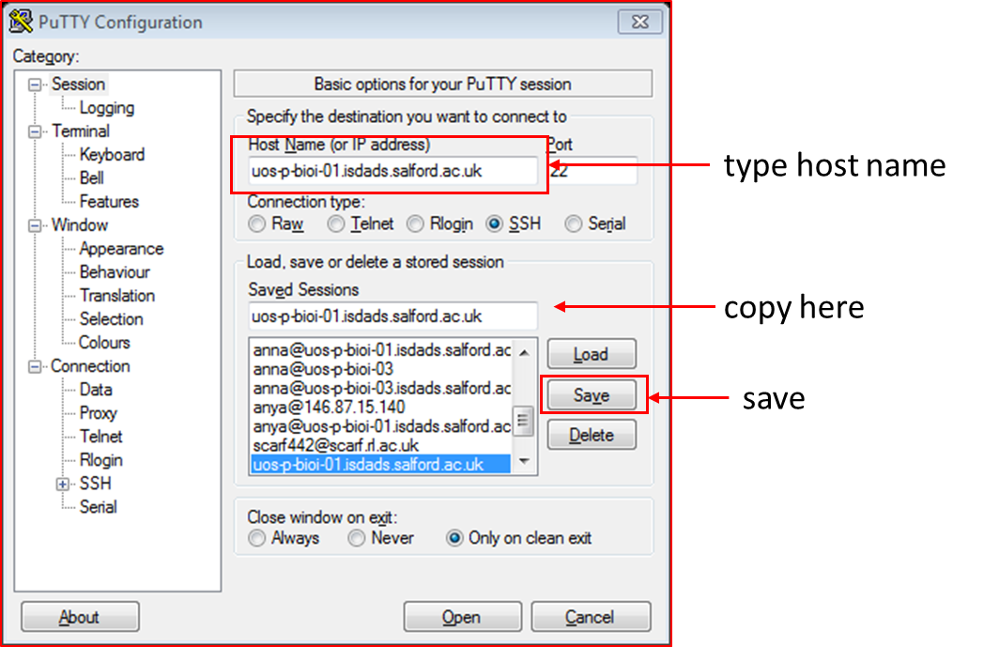

**Linux terminal (appears when you open PuTTY)**

Linux terminal is a window (usually black background with white letters), appears on your screen.

You **type commands** there (you can copy – paste from this file) but no drag-and-drop, no jumping between lines using mouse …

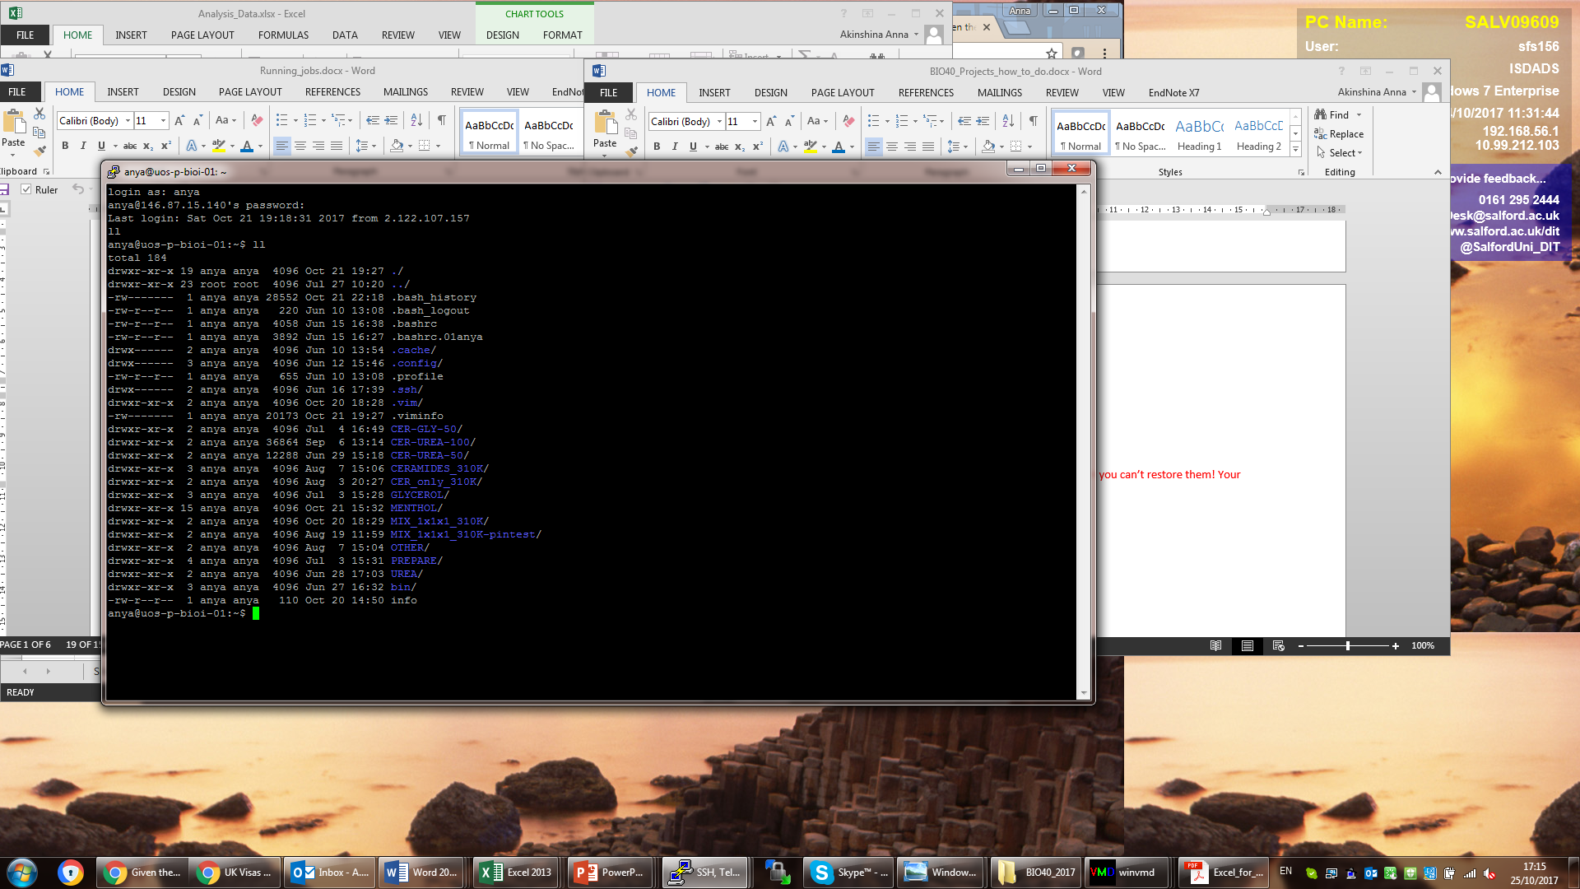

**Login to HPC server using *Terminal* app (Mac)**

Open the terminal app.

It should look like this:

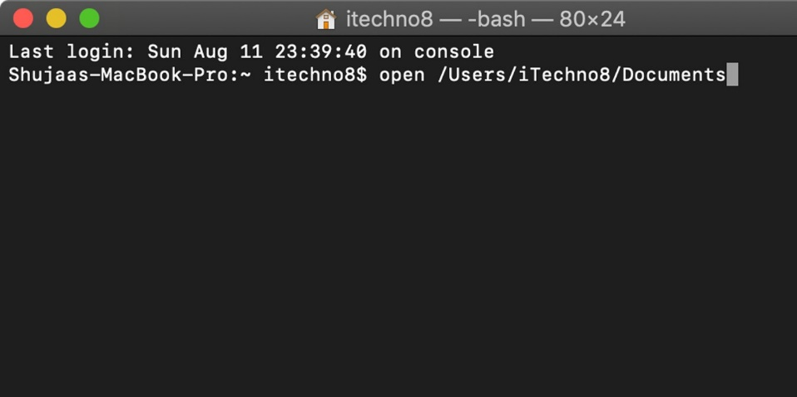

after $ sign type (ON CAMPUS):

ssh [your_username@uos-p-bioi-01.isdads.salford.ac.uk](mailto:your_username@uos-p-bioi-01.isdads.salford.ac.uk)

then type your password **(it will not show any characters – just type and hit <enter>).**

after $ sign type (HOME):

ssh [your_username@146.87.15.160](mailto:your_username@146.87.15.160)

then type your password **(it will not show any characters – just type and hit <enter>).**

You have a (unique) username in home directory of the cluster.

You create (or copy from somewhere) new directories and files under your username.

Some of the files I’ve already copied in your directories

**Membrane systems - some useful instructions**

***… Here the project starts…***

**General steps (more details of each step are below) for atomistic membranes**

* Create the membrane structure with desired lipid composition in CHARMM-GUI membrane builder <http://www.charmm-gui.org/?doc=input/membrane.bilayer>
* Copy the files (compressed) into PREP directory in Linux (create the directory if it is not there!), extract the files from *charmm-gui.tgz archive and copy specific files into designated places.
* Run the simulations (EM, NVT, NPT and MD (several steps for each simulation stage)
* Analyse your membranes (several types of analysis)

Useful video about membrane creation, analysis, force fields etc (~40 min) <https://slideplayer.com/slide/2520529/>

You don’t need specific technical details from this video (for example the problems with torsions).

**Lipids and membranes**

We will use the bilayers (two layers of lipids) to mimic a part of a membrane or lipid phase.

We will use 128 lipids in our simulations (very common number, nowadays larger number become more popular (≥ 200) but this increases also the amount of water we need to add to the system and therefore the total simulation time. Just believe me that 128 lipids are enough (64 in each leaflet). Typical bilayer looks like this:

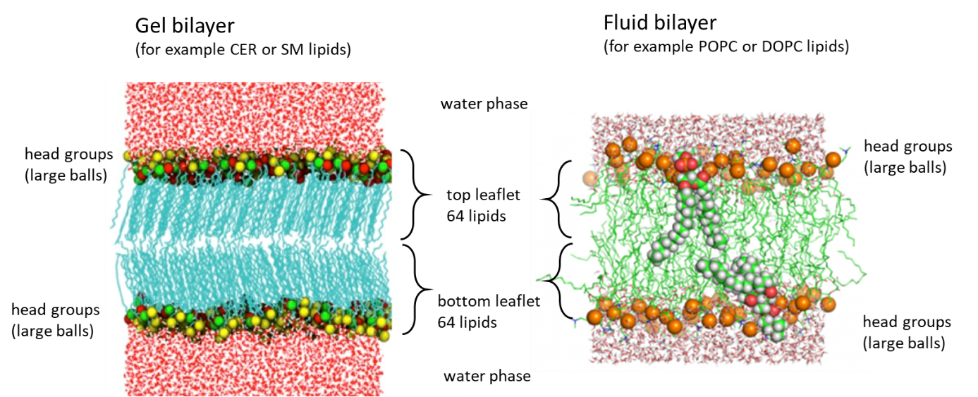

Image sources:[**https://www.r-ccs.riken.jp/labs/cbrt/tutorial/basic_md_tutorials/**](https://www.r-ccs.riken.jp/labs/cbrt/tutorial/basic_md_tutorials/)and [**https://my.vanderbilt.edu/mums/research/mccabe-group-lipid-membrane-simulation/**](https://my.vanderbilt.edu/mums/research/mccabe-group-lipid-membrane-simulation/)

**CHARMM-GUI membrane builder – create your membrane!**

Membranes (bilayers) will be created using charm-gui membrane builder.

You need to register in charm-gui website using your university email

<https://charmm-gui.org/?doc=input>

Then log in and chose input generator 🡪 membrane builder 🡪 bilayer builder

**Building the membrane requires several steps to follow.**

1) Scroll until you find a place where you can choose Membrane Only System a

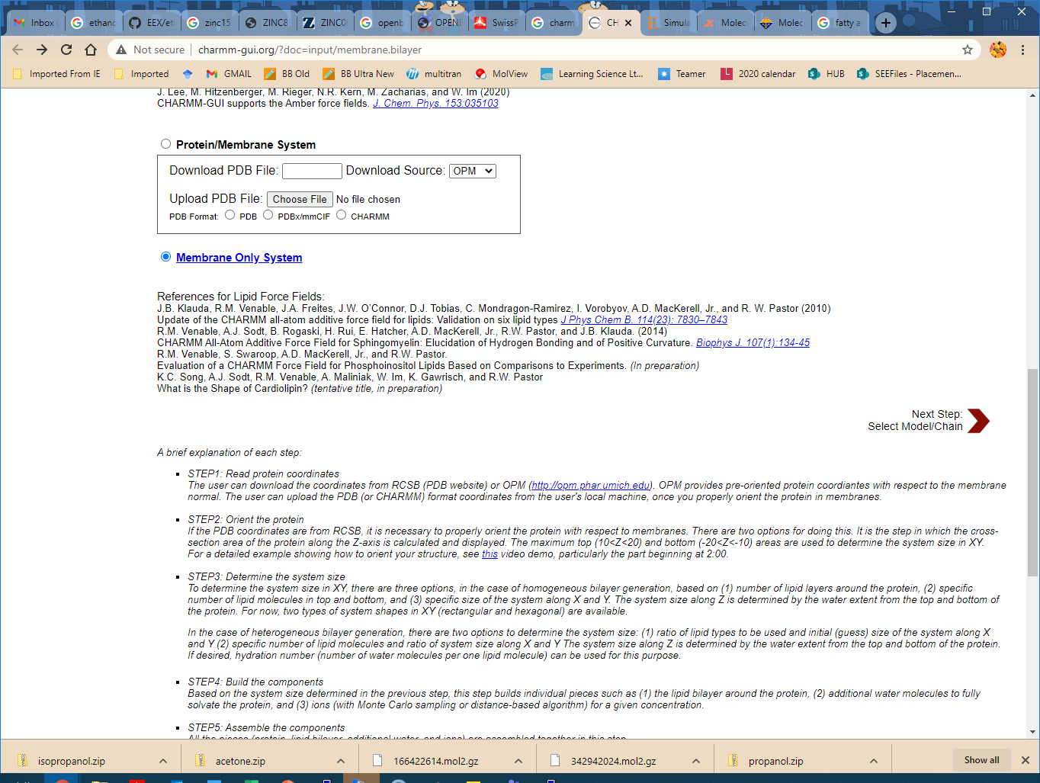

Click Next Step button (bottom right)

2) You should come to this page

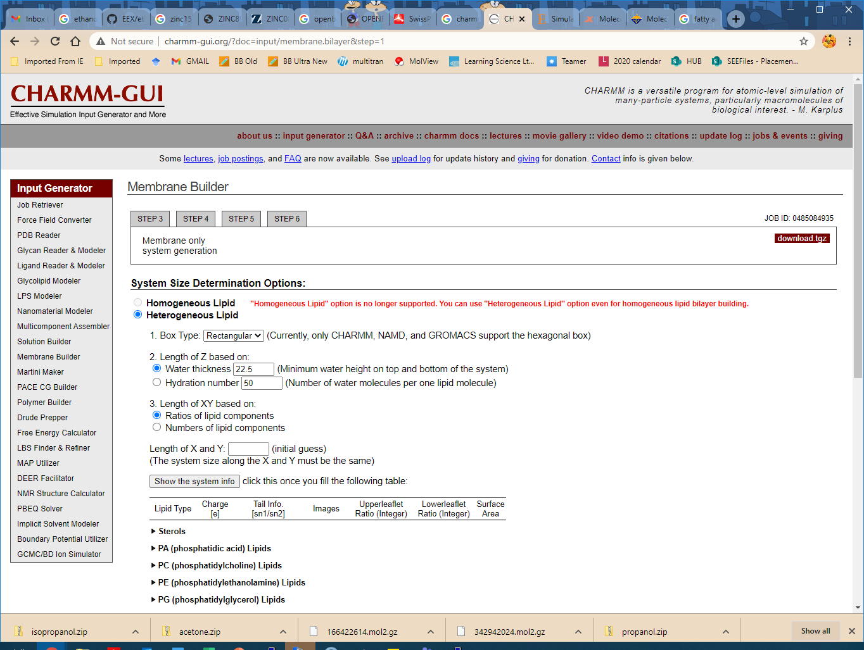

**You need to choose the following:**

Heterogeneous Lipid

Box Type rectangular

**Hydration number (tick!) 50**

Length of XY based on: Numbers of lipid components.

**Then you need to choose your lipids in specified amounts**

**For example, your lipid is POPC, you go to PC lipids and choose:**

PC (phosphatidylcholine) Lipids

POPC 64 64

**For example, your lipid is POPE, you go to PE lipids and choose:**

POPE 64 64

After you set up your lipids – click the button above the lipid list Show the system info and see if your numbers are correct. Without clicking this button next step would not work.

Click Next Step button (bottom right)

The CHARMM GUI server will do some calculations and placing lipids in a box (wait a bit)

3) You come to STEP3 but you don’t need the files yet

Go down the page and choose

*Unclick Include Ions (we have neutral system, no ions)

Click Next Step button (bottom right)

**\* If you have charged lipids**, you need to include counterions and desirably salt in physiological concentration (150 mM is OK). Charmm-gui has already calculated how many ions to add, you need to choose which one you will use. Commonly used ions are NaCl and KCl (extracellular – more NaCl, intracellular – more KCl).

Use **Insertion method** for adding ions (otherwise with replacement it could replace your lipids and that is not a good idea)

4) You come to STEP4. You don’t need to do anything. Next step will be to add water.

Click Next Step button (bottom right)

Wait a bit and

Click Next Step button (bottom right)

5) You come to STEP5. You don’t need to do anything. Next step will be building membrane together.

You need to choose:

**Force Field Options:**

CHARMM36m

**Input Generation Options:**

GROMACS

**Equilibration Options:**

Generate grid information for PME FFT automatically

NPT ensemble

**Temperature:** 310 K (physiological temperature 37C)

Click Next Step button (bottom right)

6) You come to STEP6. **You need to download the archive file** download.tgz

you can look at your membrane

Assembled PDB: step5_assembly.pdb (view structure)

Your bilayer is created and ready for simulations.

**Setting up your downloaded files in Linux server**

You need to

* [Hope this is done!] download the file download.tgz (top right corner) to your computer.
* It will download the file with a name charmm-gui.tgz
* In Linux server find or create the directory PREP (that will be used for preparation of your systems) and upload your charmm-gui.tgz file there.

To create the directory PREP, in your home type

mkdir PREP

* Go to this PREP directory and extract files using the command: tar -xzf charmm-gui.tgz

tar -xzf charmm-gui.tgz

In your home directory create a new directories (LIPIDS_AA and LIPIDS_CG) where you will be simulating your atomistic and coarse-grained lipid bilayers. In order to do so, you first need to go back to *home* from PREP directory.

cd ..

mkdir LIPIDS_AA

mkdir LIPIDS_CG

Then go back to PREP and to the new charmm-gui-xxx directory that appears after extraction of the downloaded files (it will have a specific name that I can’t predict) and then to gromacs directory.

cd charmm-gui-xxx/gromacs **(use the exact name of your charm gui directory!!! )**

* copy step5_input.gro to LIPIDS_AA
* copy topol.top file to LIPIDS_AA

cp step5_input.gro ../../../LIPIDS_AA

cp topol.top ../../../LIPIDS_AA

* go to toppar directory (inside gromacs directory)

cd toppar

copy all *itp files to your bin/top directory

cp *.itp ../../../../bin/top

Now your have everything set up for running simulations.

**Check numbers of all your components**

First, check your files, that the amount of all molecules in the system is exactly as you asked.

You can check the amounts of molecules of each type looking at your new topol.top file.

You need to check that you have 128 lipids and 6400 water molecules (50*128 = 6400).

The correct charmm-gui created system should look like this:

[ molecules ]

; Compound #mols

POPC 128

TIP3 6400

If the amount of water is different (higher or lower) that means that you haven’t clicked the option in charm-gui

[tick] Hydration number 50

so you need to create the system again 😊 and then check again the number of molecules in in topol.top again to ensure it is correct.

**Copy parameter files (*mdp) and running scripts (*sh) to your LIPIDS_AA directory**

To run simulations, you need to copy following files from bin/scripts to your running directory (LIPIDS_AA).

Go to your home directory

cd

then go to bin/scripts

cd bin/scripts

then copy all files from there to your LIPIDS_AA

cp * ../../LIPIDS_AA

Now go to your LIPIDS_AA directory and check that all needed files are actually there

cd ../../LIPIDS_AA

ll

**The files that should be there are:**

**coordinate and topology files**

step5_input.gro coordinate file from charmm-gui.

topol.top topology file (describes molecules and atoms in the system)

**mdp files**

|  |  |
| --- | --- |
| step6.0_minimization.mdp | Energy minimization. Molecules don’t move, just their angles/bonds adjusted) |
| step6.1_equilibration.mdp | First NVT equilibration – lipids are strongly fixed with position restrain |
| step6.2_equilibration.mdp | Second NVT equilibration – lipids are weakly fixed with position restrain |
| step6.3_equilibration.mdp | First NPT equilibration – lipids are weakly fixed with position restrain. Berendsen barostat and thermostat used (these are used in equilibrations of potentially unstable systems). |
| step6.4_equilibration.mdp | Second NPT equilibration – free movement of all components. Berendsen barostat and thermostat used. |
| step6.5_equilibration.mdp | Third NPT equilibration – free movement of all components. Nose-Hoover thermostat and Parrinello-Rahman barostat used (these use in production runs when system is more or less stable) |
| NPT_10ns.mdp | Longer NPT equilibration with Nose-Hoover and Parrinello-Rahman. |
| MD_50ns.mdp | Production MD-simulation |

**running scripts (run*sh) files**

run_em.sh Energy minimisation

run_nvt_1.sh First NVT equilibration

run_nvt_2.sh Second NVT equilibration

run_npt_1.sh First NPT equilibration

run_npt_2.sh Second NPT equilibration

run_npt_3.sh Third NPT equilibration

run_npt_10ns.sh Longer NPT equilibration

run_md1_50ns.sh Several scripts for 50ns production MD-simulations. We need 3 or more of them to average the data obtained.

run_md2_50ns.sh

run_md3_50ns.sh

**Topology file change – we need to tell gromacs where your files are**

You now need to change the path to the *itp files in your topology – to tell gromacs where to take the files from.

The topology should include the “#include …” statements with your *.itp files exactly in the order the molecules appear in the [ molecules ] below.

The correct statements in your topol.top file should look like this (NOT exactly – you have your lipids!):

;;

;; Generated by CHARMM-GUI FF-Converter

;;

;; Correspondance:

;; jul316@lehigh.edu or wonpil@lehigh.edu

;;

;; The main GROMACS topology file

;;

; Include forcefield parameters

#include "/extrastorage/xyz123/bin/top/forcefield.itp"

#include "/extrastorage/xyz123/bin/top/lipid.itp"

#include "/extrastorage/xyz123/bin/top/water.itp"

[ system ]

; Name

Title

[ molecules ]

; Compound #mols

lipid 128

water 6400

The important place indicated in red, the #include statement should be the path to your bin/top directory where all the *itp files are and include your username instead of a generic one /xyz123/.

**General job running cycle**

|  |  |  |
| --- | --- | --- |
| **Step 0** | Prepare initial system coordinates, topology, parameters | obtained from charm-gui |
| **Step 1** | Energy minimisation | ./run_em.sh script used.  Takes 1-2-5 min to complete. |
| When done, create an index file | | See below |
| **Steps 2-3** | NVT equilibrations (1 and 2) | ./run_nvt_1.sh  ./run_nvt_2.sh  Takes about 15-30 min each |
| **Steps 4-6** | NPT equilibrations (1,2, and 3)  short equilibration to set up densities correctly | ./run_npt_1.sh  ./run_npt_2.sh  ./run_npt_3.sh  Takes about 30 - 60 min each |
| **Step 7** | NPT equilibration 10 ns  Longer equilibration of the system | ./run_npt_10ns.sh  Takes about 12 h |
| **Step 8-10**  **or more** | MD-simulations (50 ns each) | ./run_md1_50ns.sh  ./run_md2_50ns.sh  ./run_md3_50ns.sh  Takes about 3-5 days |

You **MUST** run all these steps consecutively, one after another!

The next consecutive simulation uses previous final files as their initial files.

The order of commands

./run_em.sh

./run_nvt_1.sh

./run_nvt_2.sh

./run_npt_1.sh

./run_npt_2.sh

./run_npt_3.sh

./run_npt_10ns.sh

./run_md1_50ns.sh

./run_md2_50ns.sh

./run_md3_50ns.sh

When all the simulations are completed, we do analysis.

We will use tpr, edr and xtc files (they are binary files, you can’t look inside).

**When a step finished, a new *gro file with the final coordinates will be created.**

So,

after EM finished – em.gro will be created

after first NVT finished – nvt1.gro will be created

etc….

**Create index file**

When Energy Minimisation is completed (you will see the file em.gro - final system coordinates appears), you need to create an index file for your system (indices of all atoms)

you need to use the command gmx make_ndx

gmx make_ndx -f em.gro -o index.ndx

In the index file you need to create indices for the whole membrane that contains several lipid types.

For example, in the mono-component system:

0 System : 36352 atoms

1 Other : 36352 atoms

2 POPC : 17152 atoms

3 TIP3 : 19200 atoms

You need choose groups 2 and copy it to another group called MEMB. This means that you create another group ( group 4) that will be called MEMB. You need to do the same with water – you need to copy the group for water (TIP3) and name the new group (group 5) SOL.

you need to type:

> 2

you should get:

4 POPC : 17152 atoms

then you should rename your new group:

> name 4 MEMB

Repeat for water:

> 3

you should get:

5 TIP3 : 19200 atoms

then you should rename your new group:

> name 5 SOL

> q

**MEMBRANE ANALYSIS – Area Per Lipid (APL)**

The first type of membrane analysis is calculation of the Area Per Lipid (APL). The APL values are often calculated in simulations and experimental values are also commonly available (for most lipids). This analysis also allows to assess membrane equilibration and make conclusions if more (longer) simulations are needed.

**If the time distribution of the area per lipid is constant over a series of simulations (we will start with three final md simulations, md1, md2, md3), the membrane considered as equilibrated.**

When membrane is equilibrated, it’s time to perform other types of analysis.

The examples of an equilibrated area per lipid is presented at the figure A below and the example of not equilibrated yet is presented in the figure B:

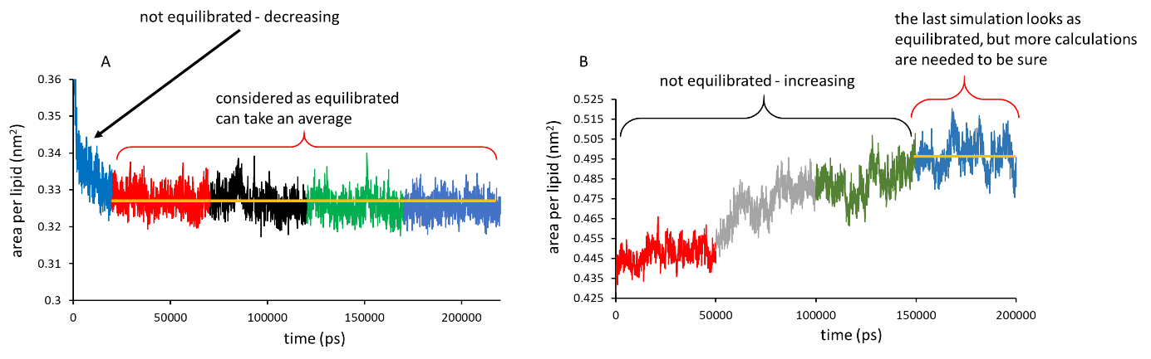

To calculate area per lipid, you need to take the XY projection of the membrane box and divide it by 64 (the number of lipids in each leadlet. If you have a different number of lipids (not 128 in total, check how many lipids in each leaflet you set up and use this number).

The figure below shows you the projected area

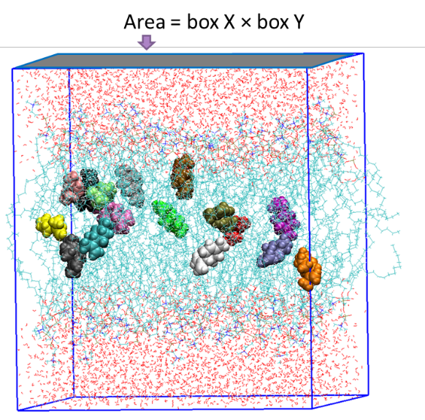

So, APL (nm2) = X*Y/64

To calculate the area, you need to use the following command:

gmx energy -f md1_50ns.edr -o XY_md1_50ns.xvg

Then you need to choose options from the prompt.

You need to choose the numbers corresponding Box X and Box Y. Often the numbers are 17 and 18 or 18 and 19.

*Please READ the options in the prompt, the numbers for X and Y could be different for different lipids.*

*Example of use:*

If the numbers are 17 and 18 you need to choose 17 (for X) 18 (for Y) and 0 (to finish).

you type:

17 18 0 <enter>

this command will produce a file called XY_md1_50ns.xvg with columns:

time X Y

…

…

Download file to your computer and make a graph in excel (calculate the area and plot it vs time)

OR copy the data from the screen to excel to make the graphs.

The template for the graphs is provided – please use it to change X and Y columns (Area Compressibility template - excel file on teams site)

**You need to do all three md simulations first to see if your membrane is equilibrated.**

I advise you also to include npt-10ns data to see how it behaved during equilibration.

Show me the graphs when you’ve done.

The template is also available at the Anna’s BIO40 teams group and the short tutorial on how to add data (from the screen or *xvg files) is in the file “Making graphs in Excel”.

**You will need to do this in atomistic and coarse-grained systems.**

Ideally you need to calculate APL values for (at least) three simulations (md1, md2, md3), calculate the average APL and standard deviation.

**MEMBRANE ANALYSIS – Compressibility modulus.**

The second type of membrane analysis is calculation of the area compressibility modulus κA.

**Area compressibility modulus κA** (pronounced as “kappa a”, Greek letter kappa) is a measure of bilayer stiffness (rigidity or flexibility).

It is calculated from the fluctuations of the bilayer projected area (A = X*Y) using the formula:



To make your life easier: the compressibility modulus κA is calculated in the same excel template automatically using the obtained previously X and Y data. Basically the template use the formula above, calculating averages for Area and Area squared in different columns and then using the final values in the formula together with Boltzmann constant value and temperature.

You will see the values for the kA in excel file if you’ve done everything correctly.

This property is good to compare with other types of membranes.

The kA values for phospholipid membranes range between 100-500 (dyne/cm), for rigid skin membranes – between 1000 – 10000 (dyne/cm). Skin membranes and the membranes containing much of cholesterol or sphingomyelin are much more rigid that those of unsaturated phospholipids (DOPC, POPC…).

More about APL and kA – see my skin lipid paper (open access) that is also available on teams <https://pubs.rsc.org/en/content/articlelanding/2016/cp/c6cp01238h#!divAbstract>

**You will need to do this in atomistic and coarse-grained systems.**

Ideally you need to calculate κA values for (at least) three simulations (md1, md2, md3), calculate the average κA and standard deviation.

**ANALYSIS – Density profiles**

The third type of membrane analysis is calculation of the density profiles for all components (lipids, water, headgroups, any specific groups you would like to focus on).

You do this analysis only for the last md simulation (md3).

Please download density.xlsx – file, the excel template for the density graphs. You can look how the partial density profile look like for a specific case on the template, but you will need to do this for your membrane and membrane components and your data most probably will look differently.

Bear in mind the Y-axis scale – yours could be different and you need to adjust it.

Partial density profiles for all the components in the system (that could include all lipids + water + ions + co-solvent + specific head groups etc.) show where different system constituents are present and how they are distributed along the simulation box.

For example, we expect that water would not go inside the membrane (as lipid tails are hydrophobic and hate water!), so the partial density profile of water should show standard values for water density (1000 kg / m3) outside the membrane and practically zero density (no water) inside the membrane.

The lipids, on contrast, should stay inside the membrane and their density in water phase should be zero.

Density profiles (mass density profiles) could be compared to literature data (simulation and experimental). Some papers publish not mass density but electron density profiles, but their shape is pretty much the same and could be used for comparison.

An example image below shows density profiles for water, lipids, lipid headgroups and the terpene limonene (a drug) for a model cancer membrane with 16 limonene molecules present (Data source: Kiran Ahmed Irfan placement report, 2020, University of Salford).

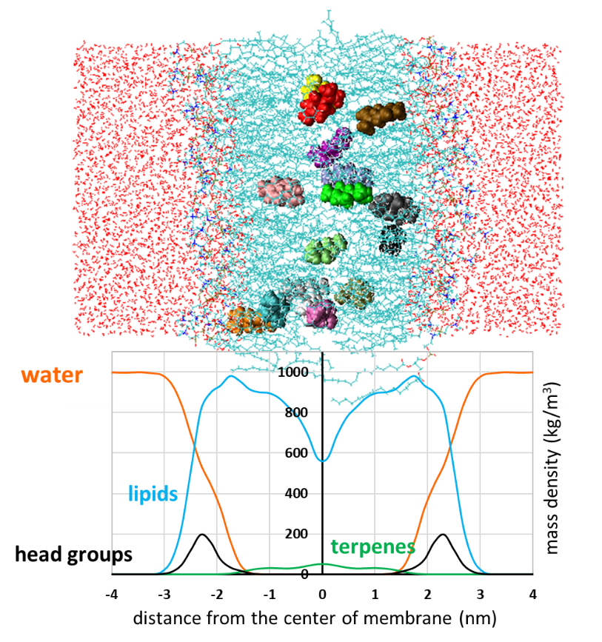

**You will need to do this in atomistic and coarse-grained systems.**

**How to calculate density profiles in practice**

First, you need to decide which components you will use for calculations of your density profiles.

Below is the example for calculating density for 3 lipids (in a complex multicomponent membrane), water, total membrane (all lipids together), ligand (drug), lipid headgroups. You may have a simpler membrane (in this case you have only one lipid type that is the same as MEMB group), no ligand, another solvent, ions etc. **You should customize the command according to your system – so please think beforehand!**

IF you need to calculate densities for lipid headgroups (this analysis is also used to calculate membrane thickness – see below), you need to add a specific group that includes major atoms (particles) from the headgroups into your index file. Common lipids usually have atoms P and N in their headgroups (you can check your lipids – see itp file for the lipid and/or see your membrane in VMD, atoms usually have specified colors and names).

You need to make a specific group for N + P atoms, so your index file when appears in prompt should looks like this (this is an example for the complex system, yours could be simpler!):

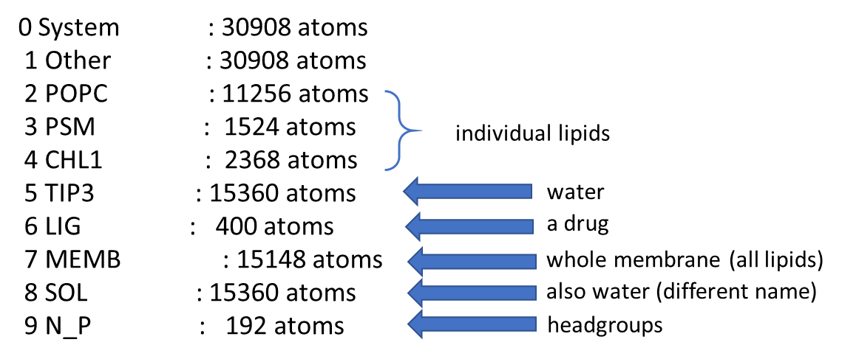

To add N & P atoms as a separate group to the index file, you need to use the command:

gmx make_ndx -f em.gro -n index.ndx -o index.ndx

in this command you take the previous index file and change it.

when the prompt asks, you need to type “a N P” after >

> a N P

so, you should see:

9 N_P : 256 atoms

The number of the new group depends on the number of components and groups in your system, so the number in the example above is 9, but yours could be different.

Think if the number is correct (256 atom). If you have 128 lipids of the same type, each containing one N and one P atom, that in total you will have 2 * 128 = 256 atoms, but if you have multi-component membrane, this number will be different (like 192 in the example above, because cholesterol doesn’t contain N and P atoms).

type q to exit

> q

So, you have a new index file. Now you need to run the density command.

Density is calculated using the *gmx density* tool (available with Gromacs).

**Below is an example of the density command using md3_50ns files.**

**Important** in this command is the flag -ng 7 (bold red) – it tells the system for how many groups to calculate density.

Count your groups before running the command!

In the example above (3 lipids, water, total membrane, ligand, lipid headgroups) it will be 7 groups, but you may have less (or more), **so adjust this number accordingly.**

gmx density -f md3_50ns.xtc -s md3_50ns.tpr -n index.ndx -center **-ng 7** -o density_md3_50ns.xvg -symm

Then you will see the prompt that will ask you

Select the group to center density profiles around:

You need to select a group for the whole membrane – MEMB. You need to type the number for it.

In this example you need to type 7 (but this could be different for other cases – read the prompt!)

Select a group: 7

Then the prompt that will ask you

Select 7 groups to calculate density for:

You need to type the numbers for the 7 groups you want to calculate the density for. If I use the index file above, the numbers will be 2 3 4 5 6 7 9. You need to type this numbers with space between them

Select a group: 2 3 4 5 6 7 9

The script will produce you a file called density_md3_50ns.xvg

You can open it in the terminal and copy the data to excel (the file is not large).

**You will need to do this in atomistic and coarse-grained systems.**

**ANALYSIS – Bilayer thickness**

To calculate bilayer thickness, we use the density profiles for the headgroups that you already obtained before.

Ideally you need to calculate density profiles for the headgroups for (at least) three simulations (md1, md2, md3), calculate the average thickness and standard deviation.

The thickness of the bilayer is commonly calculated as the distance between the two peaks in the density profiles for the head groups. Note that the *hight* of the density profile here doesn’t matter, only the distance between peaks (can you think why?).

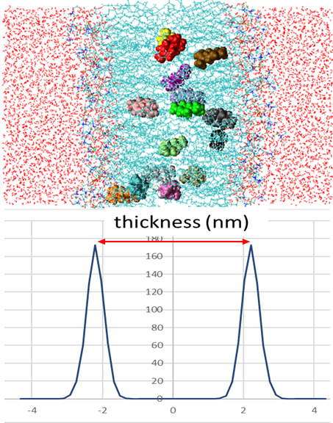

You choose the profile for the headgroups in excel file and separate the data for top and bottom leaflets (in my example in the density template those are highlighted yellow and blue). The bottom leaflet has negative values for z as the origin is in the center of the membrane.

Then you either choose the highest value in the density profile by eye or use the MAX () function in excel to show you the value for the maximum (hight).

**You need x-values (distance along the membrane) corresponding the peaks to calculate thickness.**

Then you calculate the distance between the peaks – you need to use positive x value minus negative x value (the profile should be symmetric).

In the example above the peaks are at the distances -2.207 nm and 2.207 nm, so the thickness is 2.207 – (–2.207) = 2.207+2.207 = 4.414 nm.

**You will need to do this in atomistic and coarse-grained systems.**

**\*\*\* ANALYSIS – Tail order**

Important remark.

This analysis is slightly complicated and shows your understanding of the AA & CG systems.

**You need to attempt it only of you’ve done the analyses above for both atomistic and coarse-grained membranes.**

Tail order results are different for atomistic and coarse-grained systems and without understanding *why* this is the case, you can’t compare them.

Therefore, *before* attempting this analysis

* **read** the explanations for atomistic system below and make sure you understand the protocol.

* find a literature data for a relevant coarse-grained membrane showing tail order.

* explain me why the graphs are very different.

After that we can discuss how to calculate the tail order for your system (both atomistic and CG).

If you can’t complete the (*) steps above by yourself, there is no sense to do this analysis.

**Tail order for atomistic lipids (POPC example) READ FIRST**

Tail order analysis evaluate how ordered the hydrocarbon tails with respect to bilayer normal, a vector perpendicular to membrane (xy plane) and parallel to lipid tails (z-axis). A schematic diagram of what is calculated is below.

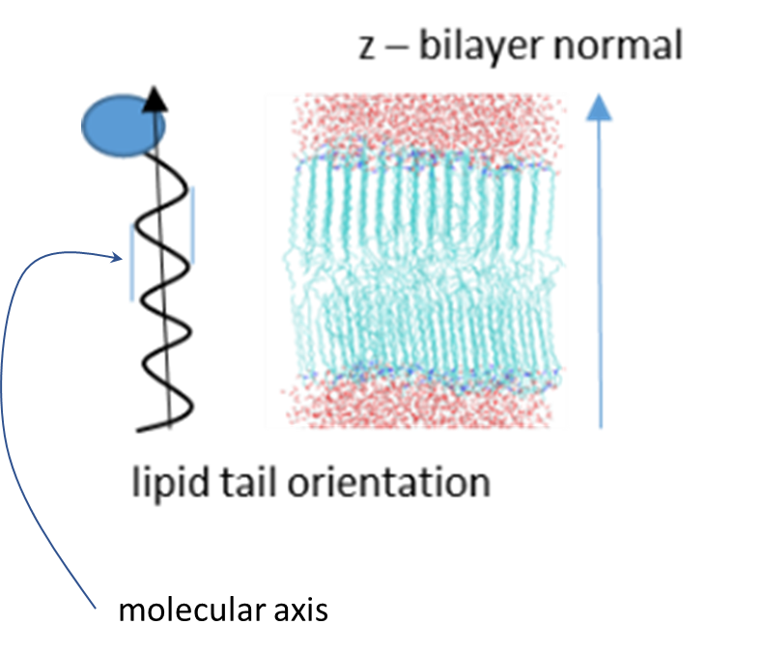

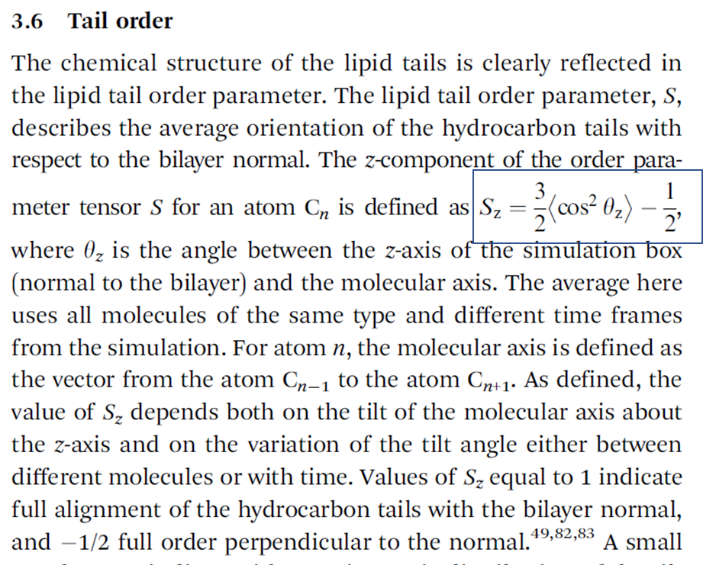

(see the rest in my skin lipid paper 2016 or C Das skin lipid paper 2009).

For the cases when the motion of the lipids around the bilayer normal is isotropic, Sz is related to the deuterium order parameter SCD measured in NMR experiments of lipids as Sz = -2SCD

You can calculate both Sz and SCD (in one go!) – you need to choose one ☺ I suggest you to find out the data in the literature you want to compare with and see which one is used, so you calculated the same parameter.

Before calculating the tail order, you need to have the index files for carbon (C) atoms in each tail (separate index files for tail 1 and tail 2).

In each index file for tails all carbon (C) atoms in this tail should be listed in order of appearance (count from the head group).

The atom numbering may have a very weird logic!

You need to open one lipid in VMD (you can open a membrane and choose one lipid, any one where you can see and mark each carbon in the tails) so you are sure what (C) atoms (names and numbers) you write in index files.

**Example of POPC lipid**

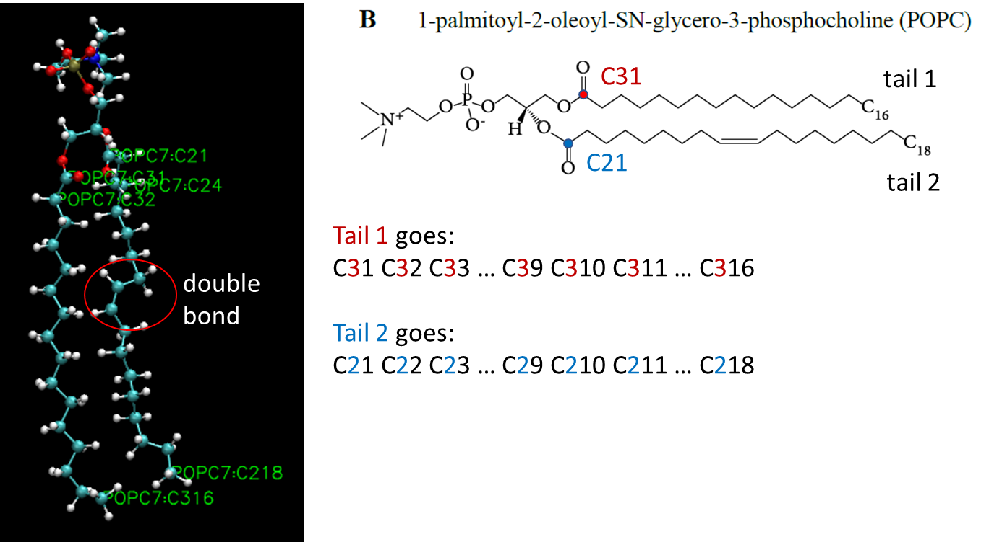

I have a script for index file creation called tail_ind_make.sh.

The script is different for different lipids and should be customised accordingly for your lipid, so if you are up to this analysis, please let me know and we discuss the best options.

You need to run the script as usual

./tail_ind_make.sh

After running, the script should produce you index files that could look something like

POPC_tail1.ndx

POPC_tail2.ndx

After that you need to use the *gmx order* tool (the *tail order* command available in gromacs) for each tail.

Example of POPC tail1 using the last simulation (md 3)

gmx order -s md3_50ns.tpr -f md3_50ns.xtc -n POPC_tail1.ndx -d z -o POPC_tail1_md4_Sz.xvg -od POPC_tail1_md3_Scd.xvg

Write here a command for POPC tail 2 (do it yourself, you should already understand the logic!)

POPC_tail1_md3_Sz.xvg – will give you the values for Sz (and also Sx and Sy – you don’t need them)

POPC_tail1_md3_Scd.xvg – will give you the values for SCD (just one column)

The xvg files for the tail order are very short, you can open them in terminal and copy all data to excel. Below is an example showing how the order of two tails may look like. The tails (saturated = blue, *cis*-unsaturated = orange) are schematically presented (not on scale, illustrative purposes only).

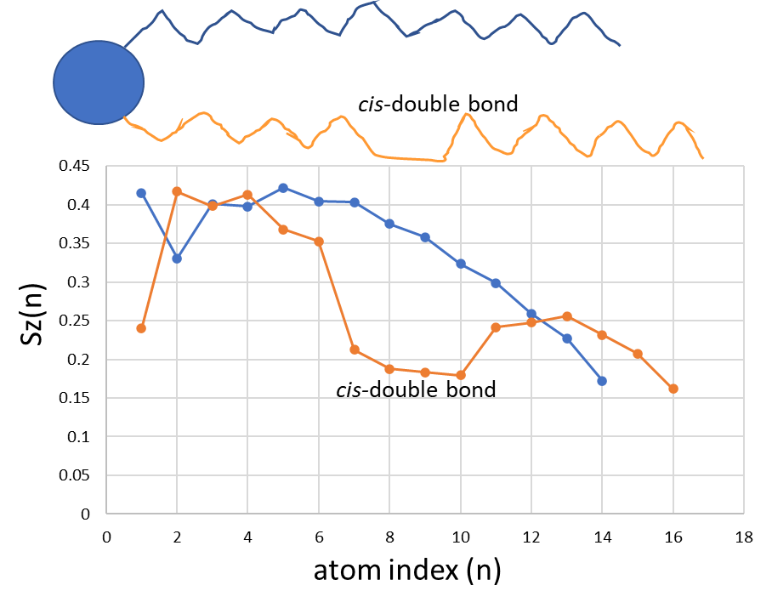

The tail order (Sz) for phospholipids is about 0.4, for PSM – about 0.6-0.7, for ceramides 0.8-0.9.

**MARTINI LIPIDS – COARSE-GRAINING**

Before attempting MARTINI lipids, please read and understand the concept of coarse-graining, the concept of presenting a molecule by so-called beads, that contain several atoms. Mapping several atoms into one bead and applying corresponding interaction parameters for beads allow to represent a module with less interactive sites. This lead to a potential for considering larger systems and quicker simulations.

Please do your best to understand the atoms to bead mapping for MARTINI force-field (the link below has a nice image for a lipid at the end)

<http://cgmartini.nl/index.php/force-field-parameters/lipids2/350-lipid-details>

and also read a good introductory paper about MARTINI

<https://pubs.acs.org/doi/full/10.1021/jp071097f>

Any questions are welcome!

**MARTINI LIPIDS – Pre-assembled membrane**

**CHARMM-GUI Martini Maker -> Bilayer Builder – create your membrane!**

Please use CHARMM-GUI interface for creation of your membrane, the process is to some degree similar to that you use for your AA system, with a few important differences.

1. Go to <https://charmm-gui.org>

2. Then log in and chose Martini Maker → Bilayer Builder

3. Read this section before start!

Create the bilayer with your lipid (bear in mind that the name could be a bit different, corresponding to your atomistic one). Use the same number of lipids as you used in your AA model.

**Important parameters** – Select Martini Model (force-field) and Choose water thickness.

At the initial step – you need to choose MARTINI force-field to use

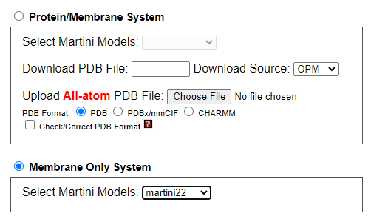

Choose **martini 22**

(if you like, you can repeat with martini 3.0.0 later – this is a newer MARTINI force-field, but it’s not available for all lipids, only for some. Please check)

**Go to next step**

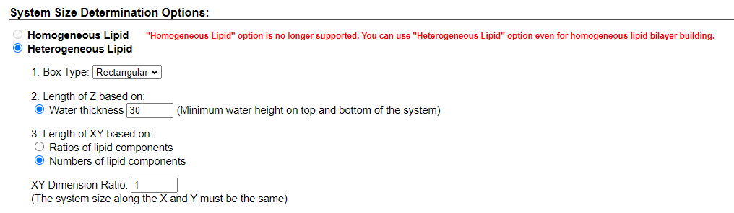

Important parameter here is **Water thickness.**

For Martini lipids you can’t specify the exact number of water modules, the only way is to “scientifically guess” the water thickness and will give you the number of water molecules close to a desirable one. I suggest you use the value 30 (instead of suggested 22.5) and see your result. Of course, you can try 22.5 first and see how many water molecules was added (it’s shown in step 5 charm-gui procedure).

Very important question first – **how many water molecules you need?**

What is the correct value?

Two things to consider: (a) you should be consistent with the atomistic values, (b) one MARTINI water bead equals to four atomistic waters (this is called 1:4 mapping).

**Calculate yourself the correct amount of MARTINI waters. Tell me your value before continuing!**

It’s advisable to a bit overestimate your thickness and number of waters because removing extra water from topology and coordinate files is easier that adding water there.

Do steps 3-4 in charm-gui (you just need to press **next step** button)

In **Step 5** you can check your water number and set up temperature at 310K.

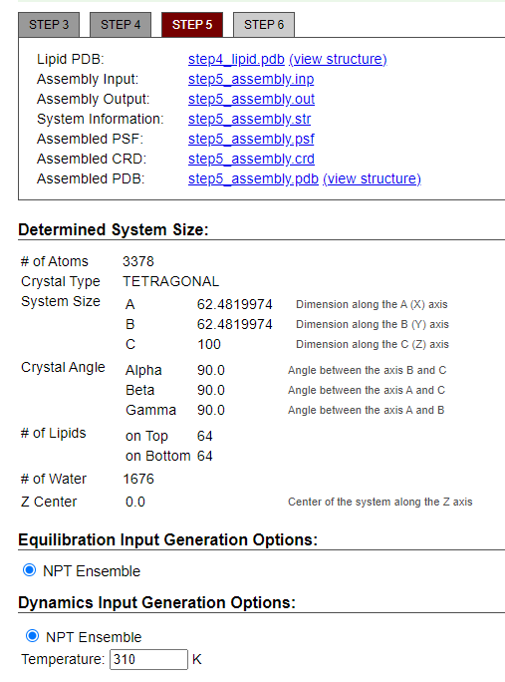

# Lipids on top / bottom 64 both (for 128 lipids)

# Water 1676 here

If you calculated your water number correctly, you should get a number of 1600 waters.

Here we have a bit more.

Of course, you can start over again with decreasing water thickness slightly aiming to have a closer value to 1600 waters.

To have exactly 1600 waters, you will need to remove 76 water beads from the coordinate *pdb file before simulation and adjust your topology (system.top) file accordingly.

4. Download download.tgz file when finished

**Running steps**

1. First go to your PREP directory in Linux server and rename the files for atomistic membrane you have there, so it will be clear what the files are. Use the commands:

for the tgz or tar file (orange / pink)

mv charmm-gui.tgz charmm-gui-atomistic.tgz

for the extracted directory for atomistic lipids (blue)

mv charmm-gui-[xxxxxxxxxx] charmm-gui-atomistic

by [xxxxxxx] I mean the numbers in your directory name, they are different for each of you.

2. Upload MARTINI *tgz file to this PREP directory

3. rename the new *tar or *tgz file so it’s clear that it contains MARTINI lipids

mv charmm-gui.tgz charmm-gui-martini.tgz

4. extract the files using the same command you used for atomistic lipids.

5. rename the new ditectory so it’s clear that it contains MARTINI lipids

mv charmm-gui-[xxxxxxxxxx] charmm-gui-martini

6. Go to this charmm-gui-martini directory and copy the topology (top), coordinate (pdb), and parameter (itp) files similar way as for atomistic.

cd charmm-gui-martini/gromacs

* copy step5_charmm2gmx.pdb to LIPIDS_CG Note that coordinate file is in pdb format
* copy system.top file to LIPIDS_CG Note that topology is called system.top

cp step5_charmm2gmx.pdb ../../../LIPIDS_CG

cp system.top ../../../LIPIDS_CG

* go to toppar directory (inside gromacs directory)

cd toppar

copy all *itp files to your bin/top directory

cp *.itp ../../../../bin/top

**Check numbers of all your components and adjust your water amount.**

1. Check you system.top file that it contains all the modules.

The correct one should look like

#include "toppar/martini_v2.2.itp"

#include "toppar/martini_v2.0_lipids_all_201506.itp"

#include "toppar/martini_v2.0_ions.itp"

[ system ]

name of the system

[ molecules ]

; name number

POPC 128

W 1600

Adjust water number (W) if it is higher than 1600

For 128 MARTINI lipids and 6400 AA water (1:4 mapping, remember?)

2. Change “toppar” to your bin/top directory for your *itp (parameter) files.

#include "/extrastorage/xyz123/bin/top/martini_v2.2.itp"

#include "/extrastorage/xyz123/bin/top/martini_v2.0_lipids_all_201506.itp"

#include "/extrastorage/xyz123/bin/top/martini_v2.0_ions.itp"

[ system ]

name of the system

[ molecules ]

; name number

POPC 128

W 1600

3*. If you have ions, please check that you have the same amount of them in your AA and CG system. As you’ve already simulated AA system, please use the same number. You will need to delete extra ions manually from *pdb file, if you have them.

4. Deleting water

In the example above 1676 water beads were added and we need just 1600, so 76 W beads should be deleted.

Open step5_charmm2gmx.pdb file in an editor (any you like – vi, nano, WinScp …)

Find where water starts and delete 76 lines for W (water) and save the file.

Below is an example showing where lipids finished and Water started.

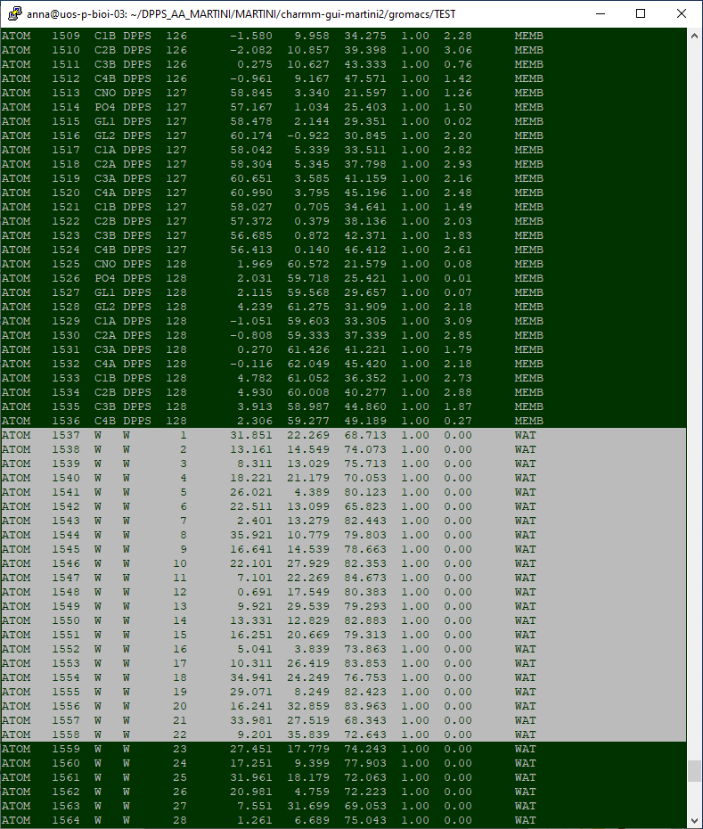

Now you are ready to do simulations.

**General job running cycle (MARTINI)**

Go to bin/martini directory

Copy all files from there to your LIPIDS_CG (you need only some of them here)

You need to complete the following steps in this order.

|  |  |  |
| --- | --- | --- |
| **Step 0** | Prepare initial system coordinates, topology, parameters | obtained from charm-gui and checked beforehand. Water number adjusted, topology (systems.top) adjusted. |
| **Steps 1-2** | Energy minimisation (2 steps)  em0 – “soft-core” minimisation.  em1 – standard minimisation | ./run_em0.sh script used.  ./run_em1.sh script used.  Takes 1 min each to complete. |
| When done, create an index file | | See below |
| **Steps 3-4** | NPT equilibrations (short) with position restraints for lipid heads to set up densities correctly | ./run_npt_1.sh  ./run_npt_2.sh  Takes 1-2 min each to complete. |
| **Step 5** | NPT equilibration 10 ns  Longer equilibration of the system | ./run_npt_10ns.sh  Takes about 5-10 min |
| **Steps 6-8**  **or more** | MD-simulations (50 ns each) | ./run_md1_50ns.sh  ./run_md2_50ns.sh  ./run_md3_50ns.sh  Takes about 15-40 min each |

You **MUST** run all these steps consecutively, one after another!

The next consecutive simulation uses previous final files as their initial files.

After you’ve done all simulations, you need to do APL, density profiles and membrane thickness analysis similar to atomistic system.

**Create index file**

When Energy Minimisation is completed (you will see the file em1.gro appears), you need to create an index file for your system (indices of all beads)

you need to use the command gmx make_ndx

gmx make_ndx -f em.gro -o index.ndx

In the index file you need to create indices for the whole membrane that contains several lipid types.

For example, in the mono-component system containing charged DPPS lipids and ions:

0 System : 2882 atoms

1 Other : 2882 atoms

2 DPPS : 1536 atoms

3 W : 1192 atoms

4 ION : 154 atoms

You need choose groups 2 and copy it to another group called MEMB. You already have a group for water (W).

you need to type:

> 2

you should get:

4 DPPS : 1536 atoms

then you should rename your new group:

> name 4 MEMB

> q

**MARTINI LIPIDS – Self-assembly into membrane**

Now it’s interesting part!

Hope you’ve completed PGR MARTINI LAB beforehand, so you understand what to expect here.

The idea is to check if you lipids can self-assembly (organise) into a bilayer in water from a random configuration. In this part you will set up a system with the same number of lipids, water (and ions if needed), but instead of pre-assembled membrane, you will put all components in a simulation box at random, simulate and assess the result.

To check if your lipid can self-assembly into a bilayer structure in water, you need to create a new directory for simulations (we run each new system in a different directory to avoid losing the data), create (or find somewhere) individual coordinate files for lipid, ions (if needed) and copy water box from PGR LAB directory.

1. In your home create a directory LIPIDS_CG_SA (or any other name you like, but a logical one!)

2. Go to your LIPIDS_CG directory

Copy system.top file to LIPIDS_CG_SA directory (it should be the same – you studying the same system with different initial configuration)

cp system.top ../LIPIDS_CG_SA

**3. Creating coordinate file for one lipid**

Find there any *gro file and select the coordinates for beads of ONE (for example first) lipid and copy the values into another file.

The numbering of molecules may not be in place (it’s different for different versions of gromacs), so you need to know how many beads are in your lipid. You can see when bead names start to repeat or check *itp file for your molecules (find it in martini_v2.0_lipids_all_201506.itp file in your top/bin)

The example when all molecules have the same number is here

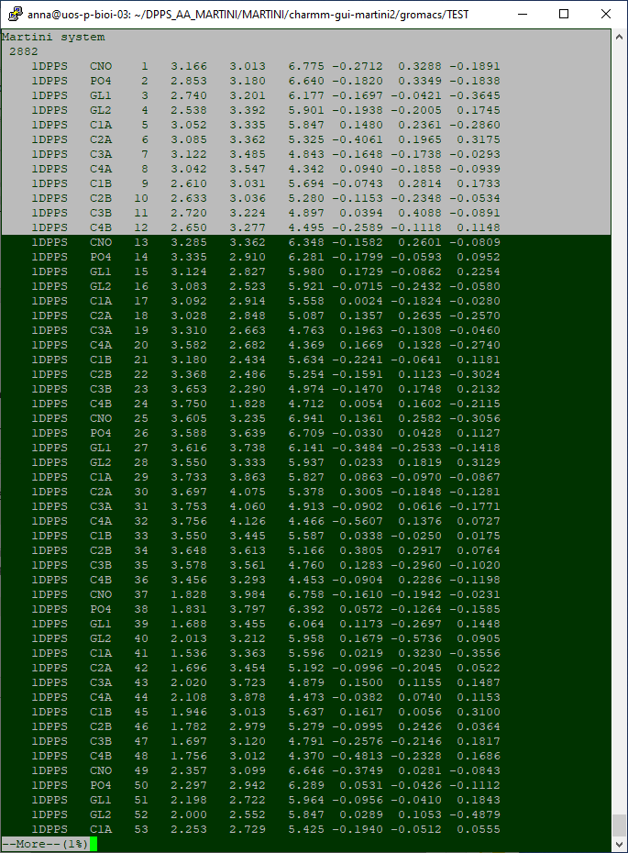

The example when all molecules are numbered differently is here

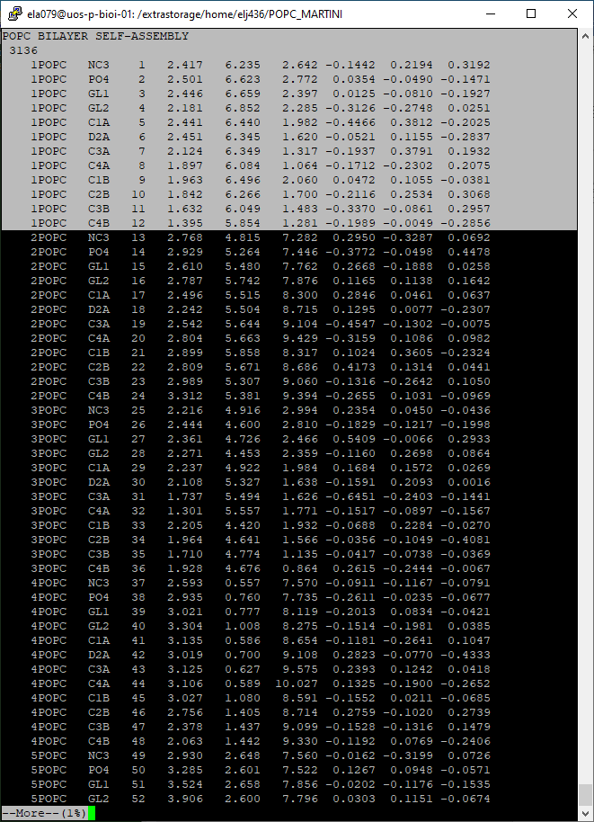

Copy the coordinates for one lipid into another file with a name your_lipid-single.gro

for example dppc-single.gro, dpps-single.gro etc.

You can do it in any editor of your choice (in linux)

You will need to change (if you want) the first line – write an appropriate name

You must change the second line – this is number of atoms (beads) in your lipid, write a correct number.

You must add a box dimensions at the end (last line), for example 10 10 10

This is an example of dpps-single.gro

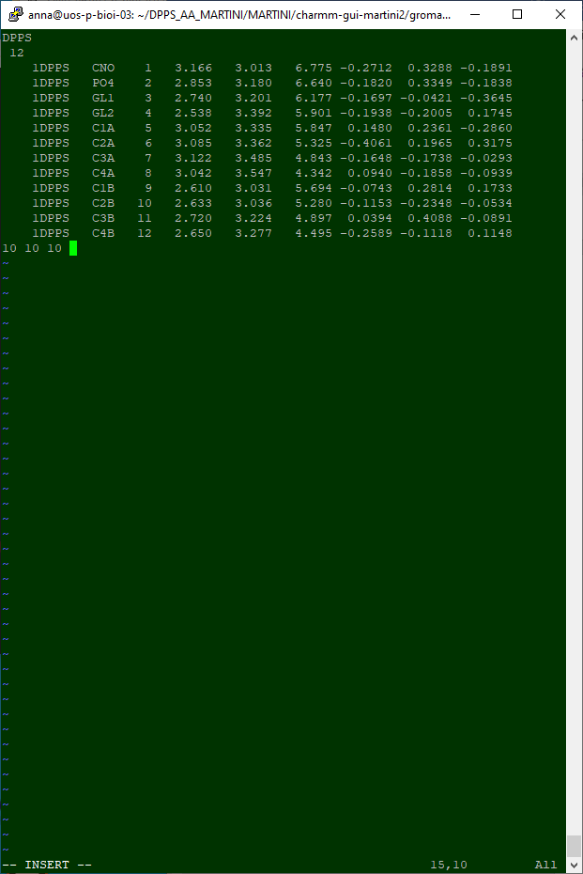

Move (or copy) this file from LIPIDS_CG to you LIPIDS_CG_SA directory (for self-assembly)

**Ions**

** If you have ions, you need to do the same for each type of ions.

It will be just one ion bead in your file and you can use smaller box dimension, for example 5 5 5.

**Example** (please don’t copy from this example, word processing messes with formatting (change amount of spaces in the lines that makes the file unreadable by gromacs).

NA

1

1ION NA 1 0.320 0.917 6.888 -0.4443 0.2402 -0.2084

5 5 5

Move (or copy) this file from LIPIDS_CG to you LIPIDS_CG_SA directory (for self-assembly)

**Copy water box**

Go to your PGR_LAB_MARTINI directory

Copy file water.gro intro LIPIDS_CG_SA

Now it’s time to create your system.

**Placing lipids in the box randomly (similar to PGR MARTINI LAB)**

Go to LIPIDS_CG_SA directory (where you will work with self-assembled system)

Make sure you have there the files: your_lipid-single.gro, water.gro, system.top (and two *gro files for ions if you need them). If you don’t have them – look in LIPIDS_CG directory, may you haven’t copied them?

1. You need to place your 128 lipids randomly using the command *gmx insert-molecules*

gmx insert-molecules -ci dpps-single.gro -box 7.5 7.5 7.5 -nmol 128 -radius 0.21 -try 500 -o DPPS.gro

When it finishes, it should write

Added 128 molecules (out of 128 requested)

Writing generated configuration to DPPS.gro

* if you have ions, you need to add the desired amount of them with the flag -nmol NNN (you need to have the same amount of each ion type as in your AA system!)

Example for Na and Cl:

gmx insert-molecules -f DPPS.gro -ci NA-single.gro -nmol 141 -radius 0.21 -try 500 -o DPPS_ions.gro

gmx insert-molecules -f DPPS_ions.gro -ci CL-single.gro -nmol 13 -radius 0.21 -try 500 -o DPPS_ions.gro

Check if systems writes that it added a desired amount of ions.

You can look at your system in VMD (download DPPS_ions.gro and look)

2. Solvate (add water)

use *gmx solvate* command

gmx solvate -cp DPPS_ions.gro -cs water.gro -o DPPS_ions_water.gro -maxsol 1600 -radius 0.21

Check if systems writes that it added a desired amount of water molecules (solvent).

Now you can start simulating!

**General job running cycle (MARTINI SELF-ASSEMBLY)**

Go to bin/martini directory

Copy all files from there to your LIPIDS_CG_SA (you need only some of them here)

**You need to change files before running and/or between the steps**

**1. Before step 1:** open ./run_em.sh script for editing

in the line for gmx grompp change the file name from DPPS_IONS_WATER.gro (the name I use for testing) to your file name (the file you just created)

**2. After step 2.** First check if your membrane is self-assembled into a bilayer.

**If not – talk to me.** We could have the case when just longer simulation needed or a different case when bilayer is not an equilibrium structure for your lipid.

**If yes,** please check if your bilayer is formed along z-direction like in the image below. Membrane analysis presume the bilayer normal is oriented along z-direction. If your membrane is oriented along x or y, you need to rotate the file (same procedure as in PGR_MARTINI_LAB).

Try rotate along one axis and then check your file!

To rotate along x-direction

gmx editconf -f npt-sa.gro -rotate 90 0 0

To rotate along y-direction

gmx editconf -f npt-sa.gro -rotate 0 90 0

To rotate along z-direction

gmx editconf -f npt-sa.gro -rotate 0 0 90

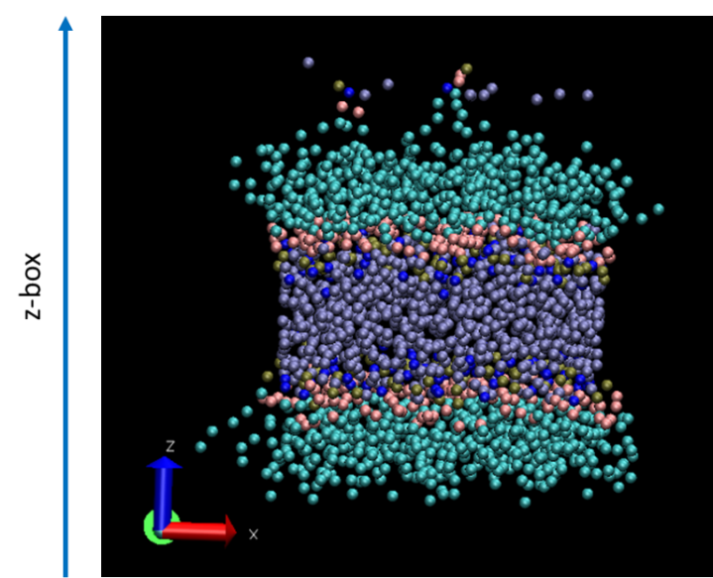

*Bilayer oriented along z-direction – you need this result*

Gromacs will save the rotated file with the name “out.gro”

Copy it to your computer and look in VMD. If it is not along z-axis, use another rotation (along another axis) and check again. When you find out what rotation gives you a correct orientation, save this out.gro file.

cp out.gro npt-sa-R.gro

**3. Before step 3.**

open your script ./run_npt_10ns.sh as you need to change the file name there

You need to tell gromacs the correct name of your initial coordinate file for this simulation.

You need to change -c npt2.gro in the script to -c npt_sa-R.gro (if you rotated the file) or npt_sa.gro (if your membrane is formed along z-direction initially).

During simulations you need to complete the following steps in this order.

|  |  |  |
| --- | --- | --- |
| **Step 0** | Prepare initial system coordinates, topology, parameters | you should have system.top file and create LIPIDS_ions_water.gro file beforehand |
| **Steps 1** | Energy minimisation | ./run_em.sh script used.  Takes 1 min to complete. |
| When done, create an index file | | As before for pre-assembled membrane |
| **Steps 2** | NPT self-assembly with isotropic pressure.  *You can look at self-assembly process using trajectories from this simulation!* | ./run_npt_sa  Takes 10-20 min to complete. |
| When done – check if membrane is self-assembled and if you need to rotate the coordinate file (npt-sa.gro). | | use VMD to check, see (2.) above for rotation command. |
| **Step 3** | NPT equilibration 10 ns with semi-isotropic pressure (for membrane) | ./run_npt_10ns.sh  Takes about 5-10 min |
| **Steps 4-6**  **or more** | MD-simulations (50 ns each)  *ideally should produce the same result as for pre-assembled bilayer* | ./run_md1_50ns.sh  ./run_md2_50ns.sh  ./run_md3_50ns.sh  Takes about 15-40 min each |

After you set-up npt_10ns to run, spend time to look into self-assembly process. The instructions are similar to that from PGR_MARTINI_LAB

Download npt_sa.gro and npt_sa.xtc (trajectories).

Open VMD and load npt_sa.gro

Load trajectories on top of coordinates to see how lipid bilayer is formed.

In **VMD Main** highlight the file npt_sa.gro 🡪 right click of the mouse 🡪 **Load Data Into Molecule 🡪 Browse 🡪 Load** file npt_sa.xtc

Enjoy!

Please repeat all analysis as for atomistic system.

So after all this has been done needs to bewritten out in correct format which I have provided above SO what I have WROTE So far;

Introduction to lipids.

Lipids are a diverse group of organic molecules that play essential roles in living organisms. They are characterized by their hydrophobic (water-repelling) nature, which distinguishes them from other biological molecules like carbohydrates and proteins. Lipids serve various functions, including energy storage, structural components of cell membranes, and signalling molecules. Focus of study is ceramide lipids specifically skin; Ceramides are a specific class of lipids that play essential roles in cellular structure, signalling, and various physiological processes.

Focusing on Lipid with the molecules that have DPCE – atomitics

Coursegrade; one;

#### So DPCE; A general model ceramide (CER) lipid corresponding to atomistic e.g., C(d18:1/18:0) N-stearoyl-D-erythron tails. – put in 64 64, when choosing lipid on charm

#### Information regarding this lipid; specific type of ceramide, a class of sphingolipids that are important components of cell membranes. Let's break down the components of the specified ceramide, C(d18:1/18:0) N-stearoyl-D-erythron tails:

#### C(d18:1/18:0): This notation represents the fatty acid composition of the ceramide. The "d18:1" indicates that the dihydroxy base (d) has an 18-carbon chain with one unsaturation at the 1st position. The "18:0" indicates an 18-carbon fatty acid with no unsaturation (stearoyl, in this case).

#### N-stearoyl-D-erythron tails: This part of the notation specifies the type of amide-linked fatty acid to the spingoid base. In this case, it's stearoyl, which is an 18-carbon saturated fatty acid. The term "D-erythron" likely refers to the stereochemistry of the glycosidic linkage to the sugar head group.

#### So, in summary, the ceramide C(d18:1/18:0) N-stearoyl-D-erythron tails is a specific type of ceramide with a defined spingoid base and fatty acid composition. Ceramides are important for maintaining the integrity of cell membranes and are involved in various cellular processes, including cell signalling and apoptosis. They are also relevant in skincare, as they play a role in maintaining the skin barrier and hydration.

Atomistic; CER180 DPCE; has water molecules of 6400and to calulate coarsegrain it’s a ration 1;4

So 6400/4 = 1600 for coarse grain water molecules

Has no ions and water molecules of 1596, with a water thickness of 35. Need 1600, so we can potentially a couple of molecules.

**My molecule ceramide is unsaturated only one bead. More info on topology files, about description. The above(info isn’t in my own words)**

THE END (so far)